Execution Performance Tester
Documentation
Version: 0

- Specification and requirements

The scope of this module to be able to precisely measure the context switching overheads in a system.

  - NIOSii Economy core based
  - No CPU caching (neither data and instruction)
  - No branch prediction support
  - Non-vectored interrupt handling
  - The core is able to detect task execution switches
  - No Multitasking support
  - Scaleable via parameters (124 different tasks / M4K block RAM)
  - Measures exception handling timings such as: interrupt latency, context saving, interrupt service routin, context restoring

- The Hardware Core

  - Conceptual block diagram - it consists of 3 different parts
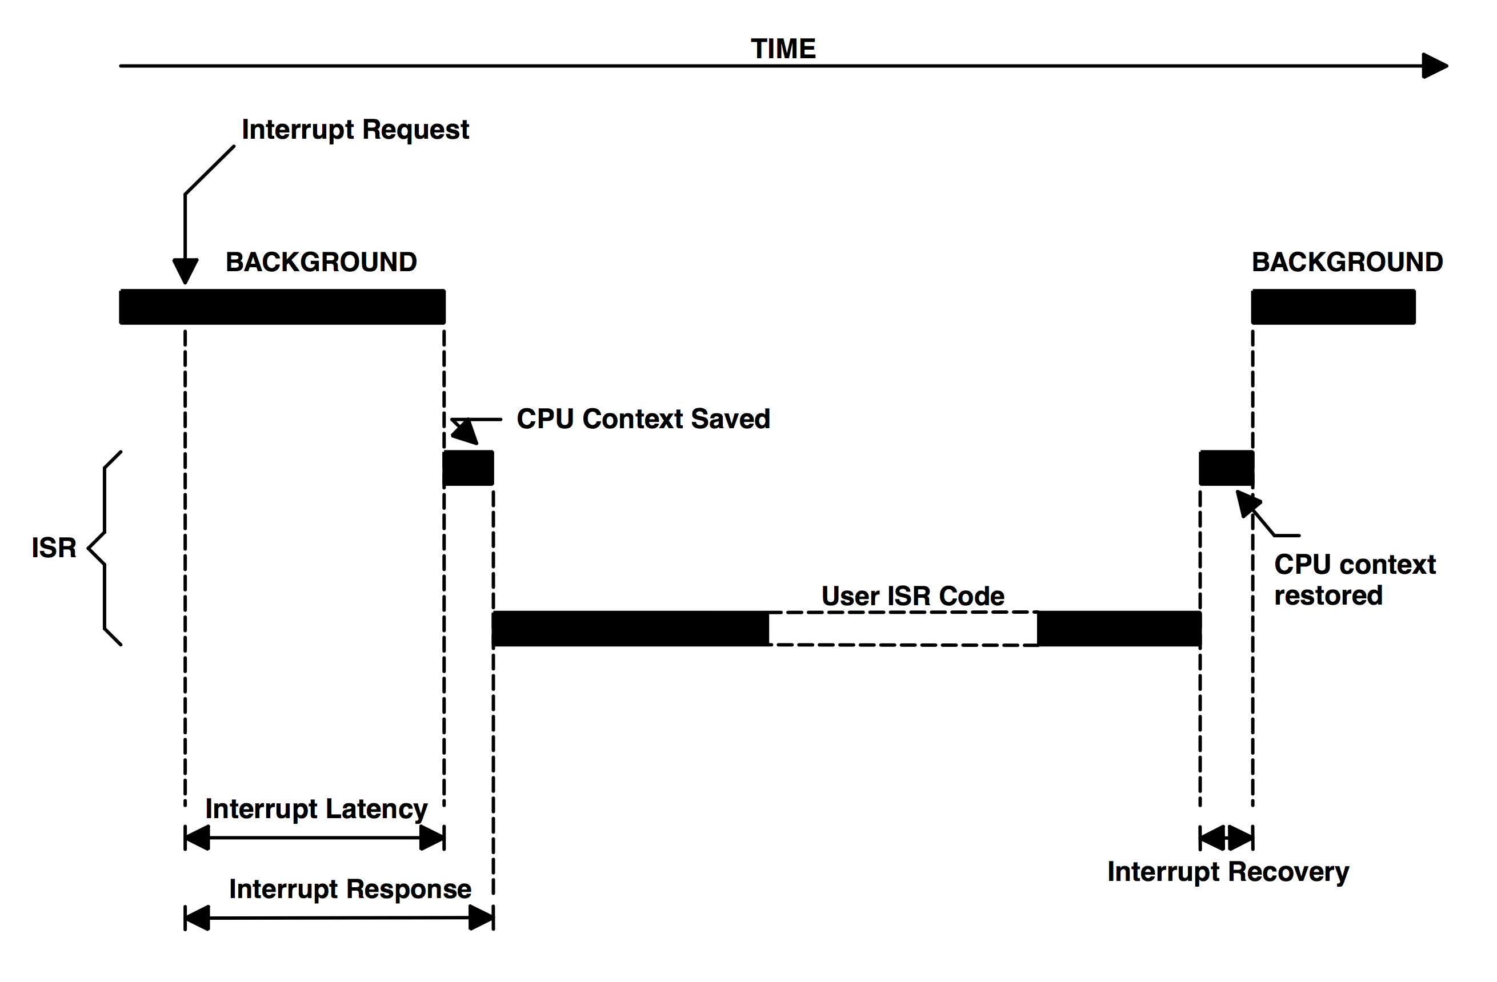
    - On-chip RAM: stores the actual measurement data (Task IDs: words-4, exception timings: 4)
    - Controller: detecting task and context switchings, putting timestamps, organizing data in the memory
    - Timestamp counter (the instance is in the controller module)
Consider 40 bit counter @ 50 MHz → (2⁴⁰-1)*20ns = 21990.233 sec total execution time (from measurement start to stop → total time).
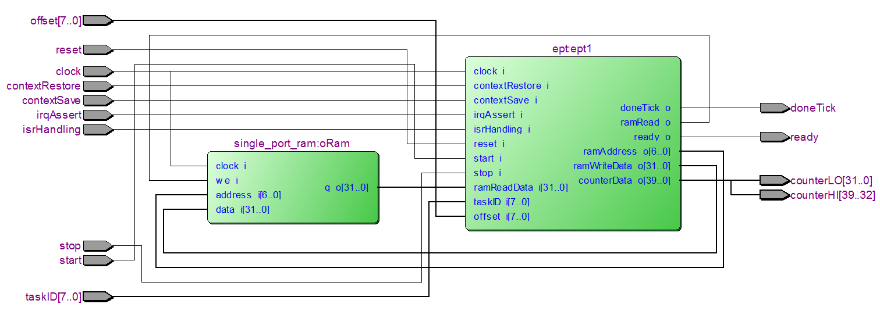

  - Using a single M4K(128x32) on-chip memory block (Cyclone II) enables to measure only 124 different tasks because the last 4 words is reserved for the exception timings. The maximum duration at 50MHz for each task and exception parameters is (2⁴⁰-1)*20ns = 85.9 sec, but currently no overflow prevention is implemented.
  - Test and function

- Memory Mapping
- Software Stack Architecture
- Functionality Tests
- I/O Offset Calibration
- Scheduler Implementation

